Templates for COVID-19 employee surveys

Employee health and wellbeing 2
Working from home arrangements 3
Communication issues 4
Technological issues 5
Security issues 5
Issues affecting the organization as a result of the pandemic 6
Risk reporting 6

***

This is a challenging time for many workplaces, especially with employees working remotely.
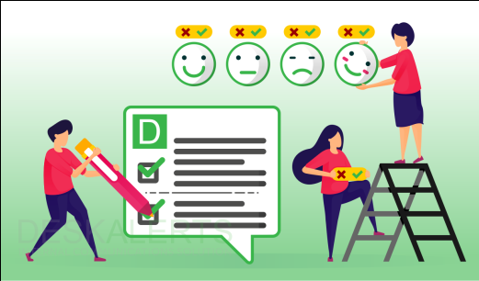
By gathering feedback from your staff members you can determine if there are any issues that you need to address to keep your organization working at its best.

These survey templates can be used in DeskAlerts and adapted to gather important feedback from your employees during the COVID-19 pandemic.

Employee health and wellbeing

Have you been diagnosed with COVID-19?
- Yes
- No

Are you displaying any COVID-19 symptoms such as fever, cough?
- Yes
- No

Have you been in close contact with anyone who has been diagnosed with COVID-19?
- Yes
- No

Have you been advised to quarantine for 14 days by a medical professional?
- Yes
- No

Are you caring for a family member who has been diagnosed with COVID-19?
- Yes
- No

Are you feeling anxious about the COVID-19 situation?
- Yes – a lot
- A little bit
- Not at all

If you are feeling anxious, do you feel it is affecting your work?
- Yes – a lot
- A little bit
- Not at all
- Not applicable

How worried are you about coronavirus affecting you personally?
- Extremely worried
- Very worried
- Somewhat worried
- A little bit worried
- Not worried at all

How worried are you about coronavirus affecting the company?
- Extremely worried
- Very worried
- Somewhat worried
- A little bit worried
- Not worried at all

What help would you like from the organization to help with your anxiety?
- Text box

Working from home arrangements

Are you aware of the organization’s working from home policies?
- Yes
- No

Do you have a proper workspace set up at home to keep working?
- Yes
- No

How satisfied do you feel about your working from home arrangements?
- Extremely satisfied
- Somewhat satisfied
- Neither satisfied or dissatisfied
- Somewhat dissatisfied
- Extremely dissatisfied

Has your optimism or pessimism about working from home changed compared to last week?

- I’m feeling more optimistic
- I feel the same
- I’m feeling more pessimistic

Are you facing any of the challenges working from home? Tick all that apply:
- Feeling socially isolated
- Finding it hard to maintain a regular schedule
- Difficulty accessing tools and information to do my job
- Problems with my physical workspace
- Interruptions and distractions at home
- My internet connection
- Communication with colleagues
- Childcare
- Being sick or caring for someone who is sick

How easy or difficult are you finding it to work effectively?
- Extremely easy
- Somewhat easy
- Neither easy nor difficult
- A little bit difficult
- Extremely difficult

How often are you keeping a regular work schedule while you’re working from home?
- Daily
- Sometimes
- Around half of the time
- Rarely
- Never

How long do you think you could comfortably maintain your current work from home arrangements?

- I’m not finding it sustainable already
- A week
- A few weeks
- A month
- Two months
- Indefinitely

Is there anything you feel you need, that you don’t currently have, to be able to do your job well while you’re working from home?
- Text box.

Communication issues

Do you feel like communication is effective in our company while everyone is working from home?
- Yes
- No
Do you feel like your team is communicating well with one another while working from home?
- Yes
- No

Do you feel like you have effective communication with your direct manager while working from home?
- Yes
- No

Do you feel like the company leadership is communicating important information effectively during the coronavirus situation?
- Yes
- No

Do you have any suggestions to improve communication within the organization at this time?
- Text box

Technological issues

Do you have the hardware and software you need to work from home?
- Yes
- No

How are you finding the technology?
- It’s as good as being in the office
- I’m experiencing some minor issues
- I’m experiencing major issues
- I’m not able to use the technology at all

If you are experiencing technological issues, what are they?
- Email
- Internet access
- Accessing software programs
- Video Conference systems
- Telephone systems

Please provide more information on your technological issues:
- Text box.

Security issues

What type of device are you using to access company systems?
- Personal device
- Company-provided device

Is your anti-virus software up-to-date?
- Yes
- No

Do you have somewhere safe to store company files and documents?
- Yes
- No

Have you come across any security concerns with working from home that management should be aware of?

- Text box

Issues affecting the organization as a result of the pandemic

How confident are you that the company will manage the crisis?
- Extremely confident
- Very confident
- Somewhat confident
- A little bit confident
- Not confident at all

What is your biggest concern about issues facing the company right now?
- Text box

Risk reporting

Have you identified any risks to the business as a result of the COVID-19 pandemic that management should be aware of? If yes, please provide more information:
- Text box

Learn more about how DeskAlerts can help you send surveys that can't be skipped or ignored → https://www.alert-software.com/survey

